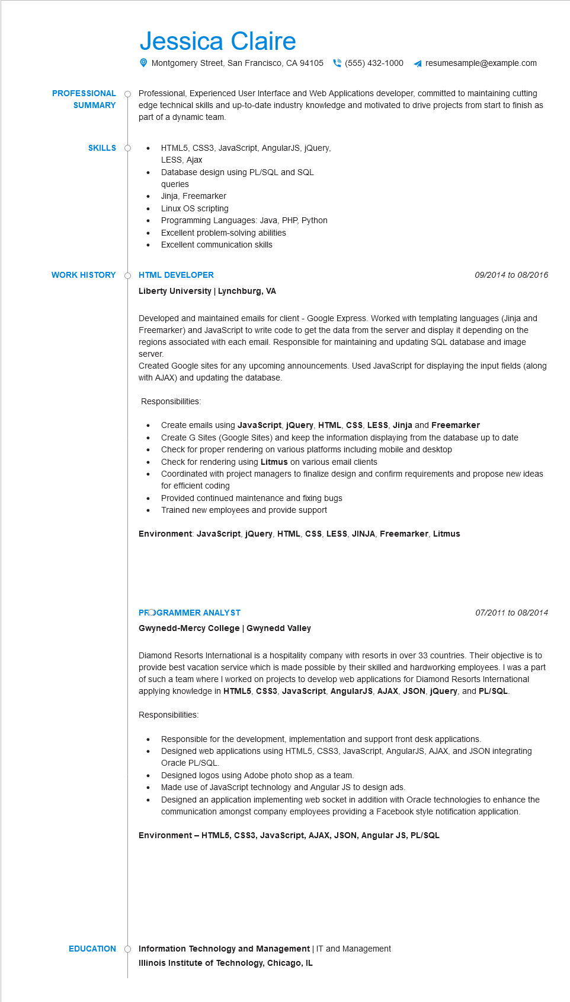
PROFESSIONAL
SUMMARY
Jessica Claire
Montgomery Street, San Francisco, CA 94105 (555) 432-1000 ◄ resumesample@example.com
Professional, Experienced User Interface and Web Applications developer, committed to maintaining cutting edge technical skills and up-to-date industry knowledge and motivated to drive projects from start to finish as part of a dynamic team.
SKILLS O
•
•
HTML5, CSS3, JavaScript, AngularJS, JQuery,
LESS, Ajax
Database design using PL/SQL and SQL
queries
Jinja, Freemarker
Linux OS scripting
Programming Languages: Java, PHP, Python
Excellent problem-solving abilities
• Excellent communication skills
WORK HISTORY
HTML DEVELOPER
Liberty University | Lynchburg, VA
09/2014 to 08/2016
Developed and maintained emails for client - Google Express. Worked with templating languages (Jinja and Freemarker) and JavaScript to write code to get the data from the server and display it depending on the regions associated with each email. Responsible for maintaining and updating SQL database and image
server.
Created Google sites for any upcoming announcements. Used JavaScript for displaying the input fields (along with AJAX) and updating the database.
Responsibilities:
•
Create emails using JavaScript, jQuery, HTML, CSS, LESS, Jinja and Freemarker
Create G Sites (Google Sites) and keep the information displaying from the database up to date
Check for proper rendering on various platforms including mobile and desktop
Check for rendering using Litmus on various email clients
Coordinated with project managers to finalize design and confirm requirements and propose new ideas for efficient coding
Provided continued maintenance and fixing bugs
• Trained new employees and provide support
Environment: JavaScript, jQuery, HTML, CSS, LESS, JINJA, Freemarker, Litmus
PROGRAMMER ANALYST
Gwynedd-Mercy College | Gwynedd Valley
07/2011 to 08/2014
Diamond Resorts International is a hospitality company with resorts in over 33 countries. Their objective is to provide best vacation service which is made possible by their skilled and hardworking employees. I was a part of such a team where I worked on projects to develop web applications for Diamond Resorts International applying knowledge in HTML5, CSS3, JavaScript, AngularJS, AJAX, JSON, jQuery, and PL/SQL.
Responsibilities:
•
•
Responsible for the development, implementation and support front desk applications.
Designed web applications using HTML5, CSS3, JavaScript, AngularJS, AJAX, and JSON integrating Oracle PL/SQL
Designed logos using Adobe photo shop as a team.
Made use of JavaScript technology and Angular JS to design ads.
Designed an application implementing web socket in addition with Oracle technologies to enhance the communication amongst company employees providing a Facebook style notification application.
Environment - HTML5, CSS3, JavaScript, AJAX, JSON, Angular JS, PL/SQL
EDUCATION
Information Technology and Management | IT and Management
Illinois Institute of Technology, Chicago, IL

